**Islamic Weekend Class**

**Daily Homework**

**Log Sheets For Students**



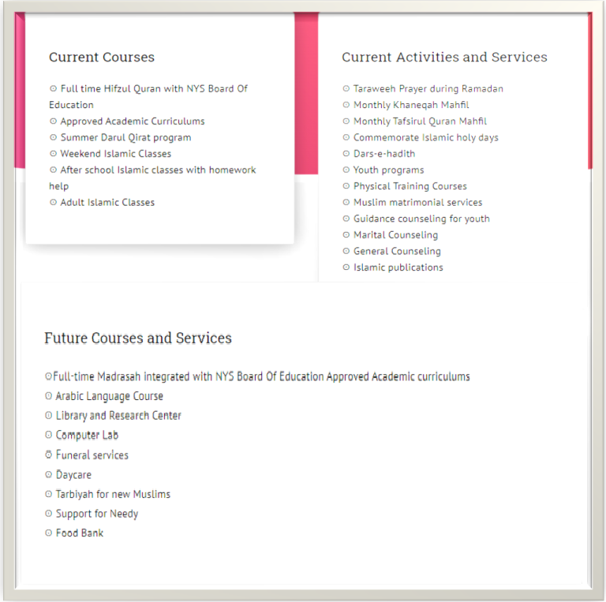

|  |  |  |
| --- | --- | --- |
| Subject | Task  Date: | Completed  Yes/No |
| Memorization Sobaq |  |  |
| Amaktah |  |  |
| Tajweed |  |  |
| Islamic Studies |  |  |

|  |  |  |
| --- | --- | --- |
| Subject | Task  Date: | Completed  Yes/No |
| Memorization Sobaq |  |  |
| Amaktah |  |  |
| Tajweed |  |  |
| Islamic Studies |  |  |

|  |  |  |
| --- | --- | --- |
| Subject | Task  Date: | Completed  Yes/No |
| Memorization Sobaq |  |  |
| Amaktah |  |  |
| Tajweed |  |  |
| Islamic Studies |  |  |

|  |  |  |
| --- | --- | --- |
| Subject | Task  Date: | Completed  Yes/No |
| Memorization Sobaq |  |  |
| Amaktah |  |  |
| Tajweed |  |  |
| Islamic Studies |  |  |

|  |  |  |
| --- | --- | --- |
| Subject | Task  Date: | Completed  Yes/No |
| Memorization Sobaq |  |  |
| Amaktah |  |  |
| Tajweed |  |  |
| Islamic Studies |  |  |

|  |  |  |
| --- | --- | --- |
| Subject | Task  Date: | Completed  Yes/No |
| Memorization Sobaq |  |  |
| Amaktah |  |  |
| Tajweed |  |  |
| Islamic Studies |  |  |

|  |  |  |
| --- | --- | --- |
| Subject | Task  Date: | Completed  Yes/No |
| Memorization Sobaq |  |  |
| Amaktah |  |  |
| Tajweed |  |  |
| Islamic Studies |  |  |

|  |  |  |
| --- | --- | --- |
| Subject | Task  Date: | Completed  Yes/No |
| Memorization Sobaq |  |  |
| Amaktah |  |  |
| Tajweed |  |  |
| Islamic Studies |  |  |

|  |  |  |
| --- | --- | --- |
| Subject | Task  Date: | Completed  Yes/No |
| Memorization Sobaq |  |  |
| Amaktah |  |  |
| Tajweed |  |  |
| Islamic Studies |  |  |

|  |  |  |
| --- | --- | --- |
| Subject | Task  Date: | Completed  Yes/No |
| Memorization Sobaq |  |  |
| Amaktah |  |  |
| Tajweed |  |  |
| Islamic Studies |  |  |

|  |  |  |
| --- | --- | --- |
| Subject | Task  Date: | Completed  Yes/No |
| Memorization Sobaq |  |  |
| Amaktah |  |  |
| Tajweed |  |  |
| Islamic Studies |  |  |

|  |  |  |
| --- | --- | --- |
| Subject | Task  Date: | Completed  Yes/No |
| Memorization Sobaq |  |  |
| Amaktah |  |  |
| Tajweed |  |  |
| Islamic Studies |  |  |

|  |  |  |
| --- | --- | --- |
| Subject | Task  Date: | Completed  Yes/No |
| Memorization Sobaq |  |  |
| Amaktah |  |  |
| Tajweed |  |  |
| Islamic Studies |  |  |

|  |  |  |
| --- | --- | --- |
| Subject | Task  Date: | Completed  Yes/No |
| Memorization Sobaq |  |  |
| Amaktah |  |  |
| Tajweed |  |  |
| Islamic Studies |  |  |

|  |  |  |
| --- | --- | --- |
| Subject | Task  Date: | Completed  Yes/No |
| Memorization Sobaq |  |  |
| Amaktah |  |  |
| Tajweed |  |  |
| Islamic Studies |  |  |

|  |  |  |
| --- | --- | --- |
| Subject | Task  Date: | Completed  Yes/No |
| Memorization Sobaq |  |  |
| Amaktah |  |  |
| Tajweed |  |  |
| Islamic Studies |  |  |